**Building corporate culture**

1. **Aptitude test result**

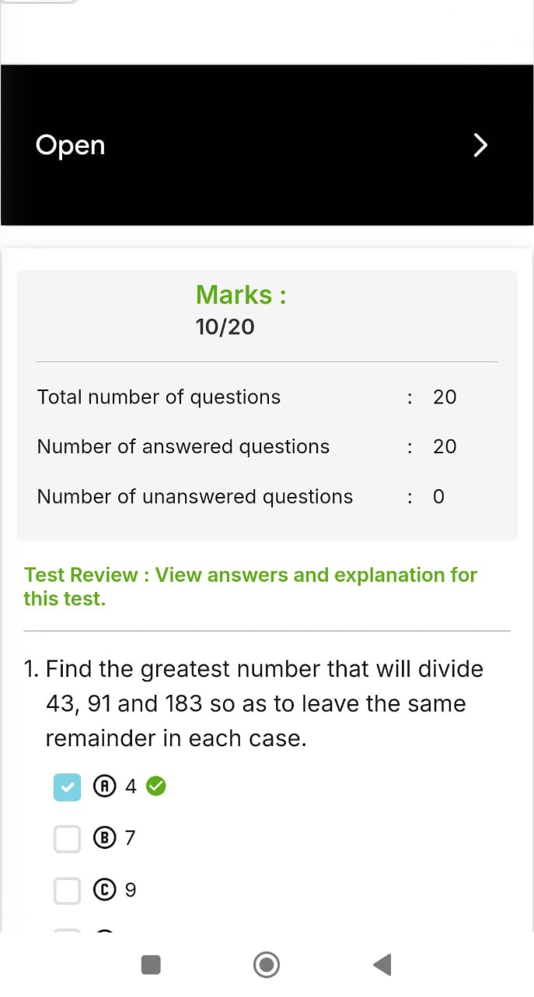

1. **Self Elevator pitch Video**

**Link:** [**https://youtu.be/L9ZsVLpbM0Q?si=nJyLCz2iJF8jVJfF**](https://youtu.be/L9ZsVLpbM0Q?si=nJyLCz2iJF8jVJfF)